
January 2010Issue 5
Head Teacher’s Introduction
Dear Parent/Carer

We are delighted that we have reached the end of January without any major incidents due to the inclement weather. The young people of Abercorn have excelled themselves with regard to behaviour and attitude during this time.

We have had our first Parent Council Meeting of the new term to arrange the AGM. This will take place over lunch on Monday 22nd February and individual invites will be in the post to you shortly. Mrs Cuzen and Miss Pollok will be joining the Parent Council from now on. I would like to thank Mr Gorman our former Vice Chair for his support over the years. I’m sure he will continue to champion Abercorn in any way he can.

Our Chinese New Year celebration in partnership with the Chinese Community was highly successful with pupils participating eagerly in this event.

This term will be particularly busy with young people in S4/S5/S6 preparing for exams and participating in Work Experience.

We really appreciate your ongoing support with
your child’s learning and behaviour and hope
that you continue to approach the school with
any concerns you may have.

Kindest Regards

Catherine McPhillips
Abercorn has decided that in response to the earthquake which has devastated Haiti, the money raised from the Non-Uniform Day on 29th January will be donated to the appeal for aid for the country.
Abercorn News
Dates for your Diary (February 2010)

Monday 1st February – Friday 5th February 2010 – Citizenship Week
Friday 12th February 2010 – In Service Day
Monday 15th and Tuesday 16th February 2010 – School Holiday
Wednesday 17th February 2010 – In Service Day

(Please note: pupils finish school on Thursday 11th February and return on Thursday 18th February)

Monday 22nd February – Friday 26th February 2010 – S4 Pupils Work Experience or Awareness

A complete diary of events scheduled to happen between now and the Summer Holidays is attached at the back of this newsletter and is also available to view on our school website.

Eco News

This term Abercorn is trying to save Energy. The staff and pupils are remembering to switch off lights and turn off computers. A team of Eco- Energy Warriors has been formed to remind Abercorn to switch off. These are from S1 Marc Stewart, Lauren McLaughlin and Leah Gilfeather, from S2 Mark Lawrence, Alistair Robertson and Jordon Rooney plus Jordon Reilly from 4D. This is important not only to contribute towards our eco-schools status but also because if the school shows a drop in Energy usage then they will receive money back from Glasgow City Council.


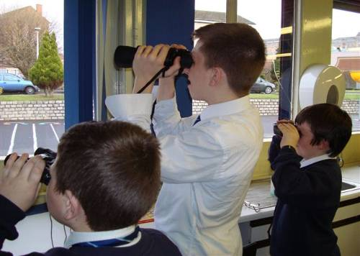
The rest of the Eco-committee members have also been busy – they were trained to identify birds by Paul Maher from the RSPB. This allowed them to take part in the Big Bird Watch Survey on 26th January which logged the birds that use Abercorn School Grounds. The results from this survey will then be displayed in school and also sent to the RSPB who will complete a national survey to see where different birds are living across Great Britain.

Finally, Abercorn’s Eco-committee would like to say a massive thanks to all those who sent in Christmas cards for recycling.
Abercorn’s First Ski Trip

In December 2009 Neil McDonald, James Morrow, Mark Wilson, Stewart Harkins, Daniel Campbell, Chris Duffy, Robbie Shaw, Jack Roach and Edward Farquhar travelled with Mr Leahy and Mrs Young to Les Menuires in the French alps for a weeks skiing.

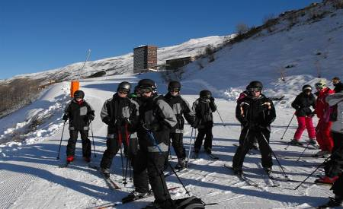
All the boys had a fantastic time in France and thought that the Skiing was 'Amazing!' after six days skiing at one of the highest resorts in Europe all the boys passed level 1 of the French Ski School's 'Ski Competency' Congratulations to Robbie Shaw who passed level 2 as well.

As you can see from the picture the weather was excellent and the conditions were perfect for our adventure.

Well done boys!!

P


PS2 Competition
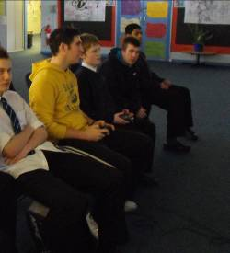
The PS2 competition organised by the ASDAN class has been running at lunch times over the past couple of months and has been a big talking point in school, especially since the final came down to a race between Darren McCluskey (3A) and Mr Baird of the PE department.

After a nail biting encounter Darren was victorious. Well done Darren!

Braidolf appeared at the Christmas Party!

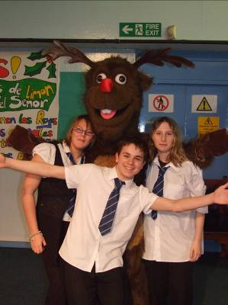
The Abercorn Crazy Entertainers group who meet on a Friday afternoon would like to thank Santa’s reindeer Braidolf (otherwise known as Gareth Gillies) for coming to entertain the pupils at their recent Christmas Party. He was a huge success with the pupils and we are very grateful that he was able to take time out from his usual festivities at Braehead Shopping Centre to come along and help make the party so successful.

S4 SVS Mock Interviews


The S4 SVS class have been busy working on a Work Awareness unit in preparation for the Work Experience Placements which they are due to undertake in February. Part of this unit is to prepare for and participate in a Mock Interview which allows them to gain and practice some of the valuable skills necessary when seeking employment. We would like to thank Alaine Fleming from Glasgow North, Audrey McJimpsey from RSBI and Matt Reilly from Right Track who came in to “interview” the pupils. They all provided a very realistic interview experience and were very impressed with the pupils they saw. They spent a great deal of time both interviewing the pupils and providing detailed feedback on their performance.

Non Uniform Days


It has been decided that there will be one Non-Uniform Day per month in Abercorn to raise money for school funds. As always, pupils are reminded that whilst they are allowed to wear their own clothes on this day, they are not allowed to wear football strips, t-shirts or tracksuits. Any pupil who does attend school in football colours will be sent home to change back into school uniform.

Chinese New Year Celebrations
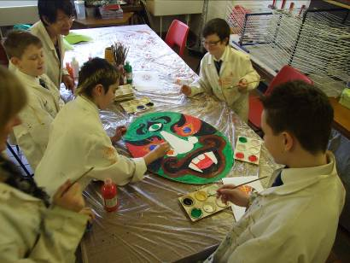
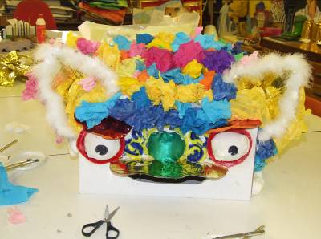
Some pupils in S1 and S2 have spent time looking at the Chinese New Year celebrations. We are very grateful to Joyce and Julia from the Chinese Community Partnership who came in to explain the background to the Chinese New Year to the group of pupils. During the workshops they worked with Miss Jaffrey in the Art Department to help the pupils make a traditional Chinese Dragon, and Miss Macintyre and Mr Baird to help the pupils prepare and perform a short play using the dragon they had made to illustrate what they had learned about the celebrations. Staff and pupils who watched the performance were very impressed.

Diary for Parents Spring / Summer Term 2010 (All dates are correct at the time of printing, but may be subject to change)

January
Tuesday 5th | School re opens
 | S5/S6 Reviews - Parents will be informed of appointments
Friday 15th | Art Prelim
Tuesday 26th | X Country Parents Council Meeting
Tues 26th | Chinese New Year Celebration
February
 | S4 Reviews - Parents will be informed of appointments
Monday 1st – Fri 5th | Citizenship week
Wednesday 3rd | Swimming Gala Eastwood
Friday 12th | In-service Day
Monday 15th and Tuesday 16th | Holiday
Wednesday 17th | In-service Day
Monday 22nd | Parent Council AGM
Monday 22nd – Friday 26th | Work Experience Week
Tuesday 23rd | X Country Bellahouston
March
 | S2 Reviews and Personalisation of Choice Meeting - Parents will be informed of appointments
Wednesday 3rd | Gala Blantyre
Tuesday 30th | Easter Service
Wednesday 31at | Abercorn’s Got Talent
April
 | S3 Reviews - Parents will be informed of appointments
Thurs 1st | School closes for Easter Break
Monday 19th | School reopens
Mon 26th – Thurs 29th | Blairvadoch
Tuesday 27th | Standard Grade Art Exam
Thursday 29th | Standard Grade English Exam
Friday 30th | In-service Day
May
 | S1 Reviews - Parents will be informed of appointments
Monday 3rd | May Day Holiday
Tuesday 4th | Standard Grade and Int 1/2 Administration exam
Wednesday 5th | Standard Grade Maths Exam
Monday 10th | Standard Grade Computing Exam
Wednesday 12th | Standard Grade SVS Exam
Thursday 13th | Intermediate 1 /2 English Exam
Friday 14th | Intermediate 1 Business Management Exam
Thursday 20th | Festival of Sports Kelvinhall
Friday 21st | Intermediate 1 Maths Exam
Tuesday 25th | Standard Grade Modern Studies Exam
Friday 28th and Monday 31st | May weekend holiday
June
 | S5/S6 Trip to Spain (Date to be confirmed)
Thursday 3rd | Sports Event Kelvinhall
Thursday 3rd | Intermediate 1 Computing Studies
Thursday 3rd | Lion’s Den
Friday 4th | Intermediate 1 Spanish Exam
Monday 7th – Friday 11th | Health and Wellbeing week
Thursday 10th (prov) | Prom
Tuesday 22nd | Awards Ceremony
Friday 25th | School closes for summer

