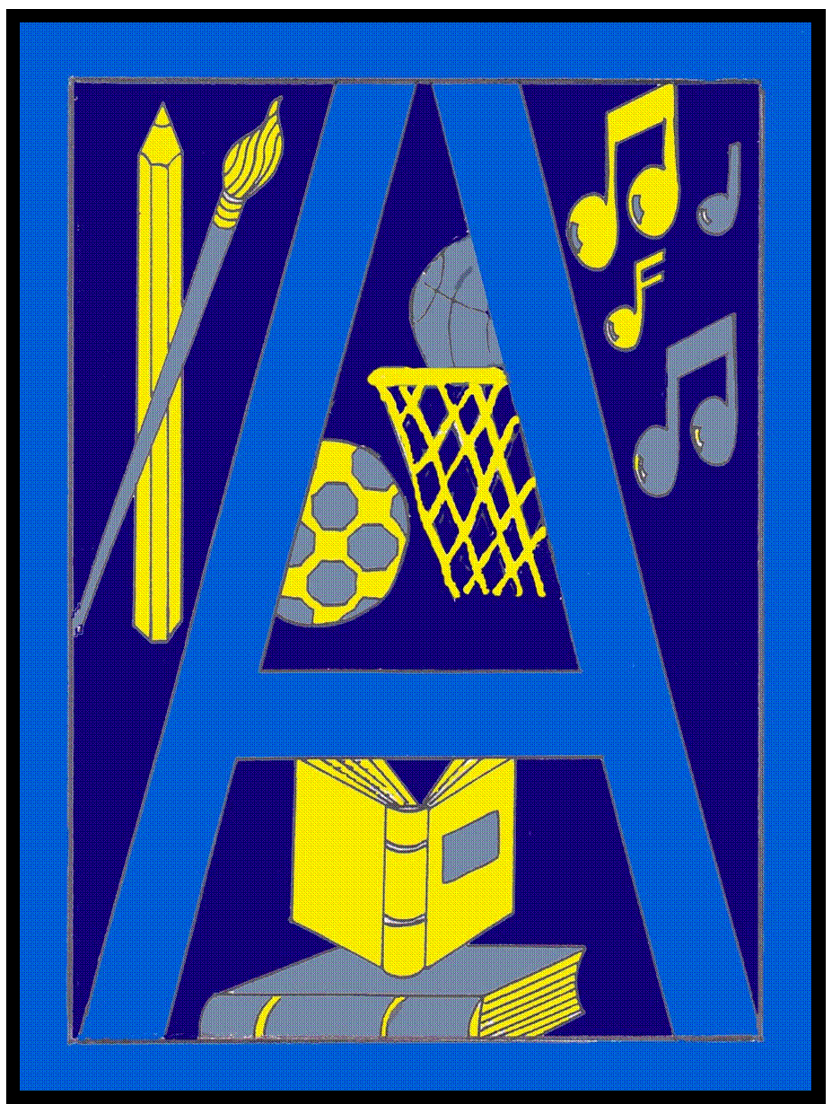

February 2010Issue 6
Head Teacher’s Introduction
Dear Parent/Carer

I am happy to report that our Parent Council AGM Lunch on Monday 22nd February was a great success.

Forty parents attended and the feedback was very positive. Our Parent Council are keen to represent the views of parents and I am personally committed to listening to your opinions. I intend to include a tear-off slip in subsequent newsletters and if you have any issues you would like to raise please put your name and telephone number on the slip and I will get back to you.

Furthermore, if you would like to speak to the Parent Council about any issues or ideas you may have please telephone the school on 0141 332 6212 to arrange an appointment.

I would like to take this opportunity to thank you once again for your ongoing support. It really makes a difference.

Kindest regards

Catherine McPhillips
As we go to press, our new minibus is due to be delivered soon. We are very grateful to Theresa Fraser of Tube Developments who have sponsored this bus for us. Pictures to follow!!
Abercorn News

Dates for your Diary (March 2010)

Thursday 4th March 2010 – S1 – S3 Visit to Science Centre
Thursday 4th March 2010 – S2 Parents/Carers Meeting to discuss Personalisation and Choice for S3 1.30pm
Friday 19th March 2010 – Sports Relief Non-Uniform Day with fund raising activities
Thursday 25th March 2010 – Bingo Night to raise funds for Post 16 trip to Spain
Tuesday 30th March 2010 – Easter Service
Wednesday 31st March 2010 – Abercorn’s Got Talent (Organised by Abercorn Crazy Entertainers)

Also throughout March the S2 Reviews will take place following distribution of the Reports. S2 parents/carers will be advised of the dates for these meetings in due course.

Glasgow Sports Person of the Year Awards 2009


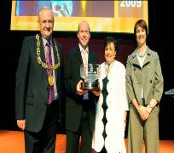
We were recently honoured during the prestigious 2009 Glasgow Sports Person of the Year Award Ceremony. Organised by Culture and Sport Glasgow, the annual ceremony is hailed as one of the highlights of the city’s sporting calendar and celebrates the talent and commitment of the countless individuals and sports teams from across the country. Having been nominated in the Glasgow Sports Secondary School of the year we were disappointed to narrowly come second to Hillhead High School. It was however, a very nice surprise to then discover that Abercorn had been awarded the Lord Provost’s Award in recognition of the vast number of sporting achievements in our school. Speaking at the event, Bob winter, Glasgow’s Lord Provost said “Glasgow is a sporting city, a place that loves to compete and thrives on taking part. These awards are instrumental in channeling the excitement surrounding the 2014 Commonwealth Games to further inspire our young people to make health and fitness an integral part of their lives.” Glasgow Councilor Archie Graham said “This year’s winners included not only elite athletes but some of Glasgow’s unsung sporting heroes – a true reflection of this city’s passion for sport at all levels.”
Everyone in the school is delighted and very proud to have our achievements recognised at such a high level.

S4 Work Experience and Work Awareness Week


All S4 pupils experienced the world of work during the week beginning 22nd February. Some were on Work Experience placements with a variety of employers including City Building (Glasgow), RSBI, WH Smith, GAME and various hairdressers and Nurseries. As always we are very grateful to the many employers who take our pupils for this very valuable week of work experience. Those who were not out of school on Work Experience Placements took part in a Work Awareness week designed to introduce them to the many different aspects of the world of work. They attended talks by employers in many different industries and also heard from former pupils of Abercorn about the employment opportunities they had gone on to find after leaving school.

Post 16 Trip to Spain

Preparations are well under way for the annual trip to Spain for Post 16 pupils. This is the culmination of many years of studying Spanish as a foreign language throughout their time in Abercorn and the trip allows pupils to experience the language, food, culture and attractions which Spain has to offer. To contribute towards the cost Miss Jaffrey has devised a fun quiz. It costs £1 to enter and quiz sheets can be obtained from Miss Jaffrey, Mrs Beaton or Miss Campbell. There are Marks and Spencer vouchers for the winners and the runners up. Entries must be in by 15th May.

Show Racism the Red Card Competition

stop press news – We have just heard from the organisers that Billy Nicholson 2A has been selected as a finalist in the Show Racism the Red Card Competition. Pupils had linked their Modern Studies and Art & Design work to enter this competition by producing a range of posters, t-shirt designs, animations and power-point presentations. Billy will attend a prize giving ceremony at Hampden on the 25th March with a group of other pupils to hear the winners being announced. We are keeping our fingers crossed he will be successful and will keep you posted with the results. Well done to everyone who took part in this competition. We will get our entries back and put them on display for everyone to see!

Sports Relief
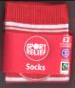
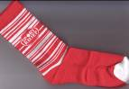
Sport Relief is coming up again – Abercorn will be supporting Sport Relief again this year. The pupils asked us to take part in the socks for schools scheme again, which means that we have this years Sports Relief Socks for sale in school. Socks are £2 a pair and are on sale from Miss Walsh in Modern Studies. There will be a non-uniform day on Sports Relief day - Friday 19th March as well as some other activities. All money raised goes to the work of Sport and Comic Relief, which the pupils of Abercorn have a great track record of supporting!
Determined to Make Movies Competition

W e are delighted to let you know that ‘Cool Street – Episode 1’, produced by the HWB Drama and Art & Design group, was one of the finalists showcased at the awards ceremony at the Glasgow Film Theatre on Sunday 7th Feb. We were nominated in 3 categories:- Best Drama, Best DVD cover and Best Actress/ Presenter for Patsy Gorman S6. A number of staff and pupils attended the ceremony with their parents and we were delighted to discover we’d won 2nd place in the Best Drama Category. Emma Duncan, Max Miller, Corey Clark and Patsy Gorman represented the school by going forward to receive our Highly Commended award.
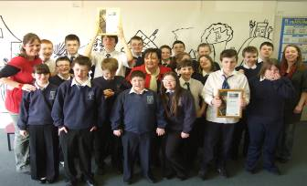
Valentine’s Celebrations

4C/D made Valentines Gift Boxes and provided a ' Valentines Postcard and Delivery Service' to pupils in Abercorn on Thursday 11th February 2010. The gift boxes were handmade and contained a sweet surprise. The gift boxes proved to be a hit and sold out! All money raised to be donated to the DEC appeal for aid in Haiti.

